***ANUDIP FOUNDATION***

A Project Report on

**EVENT MANAGEMENT SYSTEM**

By

Batch: ANP-D0453

Student ID: AF0477058

Name: Mayuri Shriniwas Samal

**Under the Guidance of**

Mrs. Rajshri Chandrabhan Thete

**EVENT MANAGEMENT SYSTEM**

The **Event Management System (EMS)** is a comprehensive solution designed to simplify and streamline the process of organizing various types of events. It automates key tasks such as scheduling, venue selection, assigning organizers, registering attendees, and managing vendors.

By reducing manual efforts and minimizing errors, the system ensures that event planning and execution are smooth and efficient. All event-related information is stored in one place, allowing easy access for updates and decision-making.

The system allows event organizers to easily add, update, view, and delete event information while maintaining detailed records of venues, organizers, attendees, and vendors. This centralized approach ensures that all event-related data is stored securely and can be accessed quickly whenever needed.

By offering a structured and organized way of managing events, the Event Management System saves time, improves efficiency, and contributes to the successful execution of events.

Overall, the Event Management System enhances the efficiency of event planning, making the process faster, more organized, and hassle-free.

**ENTITIES**

1. Event
2. Venue
3. Organizer
4. Vendor
5. Attendee

**ATTRIBUTES**

1. **Event**

* E_id (Primary key)
* E_title
* E_Type
* E_DateTime
* E_Time
* V_Id (Foreign key)
* O_id (Foreign key)

1. **Venue**

* V_id (Primary key)
* V_Name
* V_Address
* V_Contact
* V_Owner

1. **Organizer**

* O_id (Primary key)
* O_Name
* O_Address
* O_Email
* O_Role

1. **Vendor**

* Vend_Id (Primary key)
* Vend_Name
* Vend_Contact
* Vend_Fee
* Vend_Details
* E_Id (Foreign key)

1. **Participants**

* P_Id (Primary key)
* P_Name
* P_Contact
* P_Status
* P_Performance
* E_Id (Foreign key)

**ENTITY RELATIONSHIP DIAGRAM**

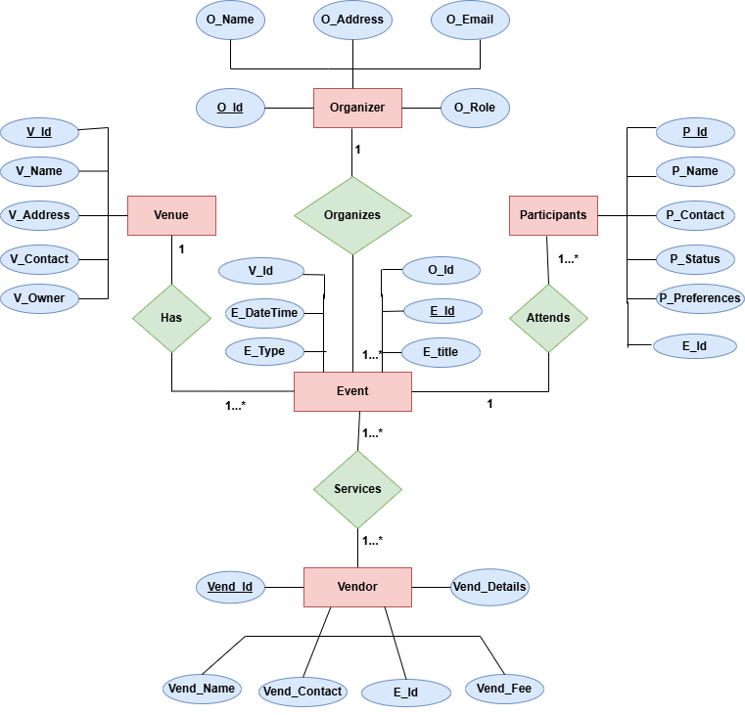

**CONCLUSION**

In conclusion, the Event Management System (EMS) provides a reliable and efficient solution for managing various types of events with ease. It simplifies the complex process of event planning by automating tasks such as managing event details, assigning venues and organizers, tracking attendees, and coordinating with vendors. By centralizing all event-related information, the system reduces errors, saves time, and enhances overall productivity.

The system's ability to handle multiple operations ensures smooth execution and better communication between all stakeholders involved in the event. It also offers valuable insights through reports that help in evaluating the success of events and improving future planning. Overall, the Event Management System significantly improves event organization, ensuring seamless operations and contributing to the success of any event.

**DATABASE CREATION QUERY:**

mysql> CREATE TABLE Organizer (

-> O_id INT PRIMARY KEY,

-> O_name VARCHAR(255),

-> O_Addess VARCHAR(255),

-> O_Email VARCHAR(255),

-> O_Role VARCHAR(255)

-> );

Query OK, 0 rows affected (0.16 sec)

mysql> CREATE TABLE Venue (

-> V_id INT PRIMARY KEY,

-> V_name VARCHAR(255),

-> V_Addess VARCHAR(255),

-> V_Contact VARCHAR(20),

-> V_Owner VARCHAR(255)

-> );

Query OK, 0 rows affected (0.03 sec)

mysql> CREATE TABLE Event(

-> E_id INT PRIMARY KEY,

-> E_Title VARCHAR(255),

-> E_Type VARCHAR(255),

-> E_DateTime VARCHAR(255),

-> O_id INT,

-> V_id INT,

-> FOREIGN KEY (O_id) REFERENCES Organizer(O_id),

-> FOREIGN KEY (V_id) REFERENCES Venue(V_id)

-> );

Query OK, 0 rows affected (0.13 sec)

mysql> CREATE TABLE Participants(

-> P_id INT PRIMARY KEY,

-> P_name VARCHAR(255),

-> P_Contact VARCHAR(20),

-> P_Status VARCHAR(20),

-> P_Preferences VARCHAR(20),

-> E_id INT,

-> FOREIGN KEY (E_id) REFERENCES Event(E_id)

-> );

Query OK, 0 rows affected (0.06 sec)

mysql> CREATE TABLE Vendor (

-> Vend_id INT PRIMARY KEY,

-> Vend_name VARCHAR(255),

-> Vend_Contact VARCHAR(20),

-> Vend_Fee VARCHAR(20),

-> Vend_Details VARCHAR(255),

-> E_id INT,

-> FOREIGN KEY (E_id) REFERENCES Event(E_id)

-> );

Query OK, 0 rows affected (0.08 sec)

**Tables_in_event_mgt_system**

mysql> show tables;

+----------------------------+

| Tables_in_event_mgt_system |

+----------------------------+

| event |

| organizer |

| participants |

| vendor |

| venue |

+----------------------------+

5 rows in set (0.01 sec)